TSASA Treasury Wallet
a step-by-step guide
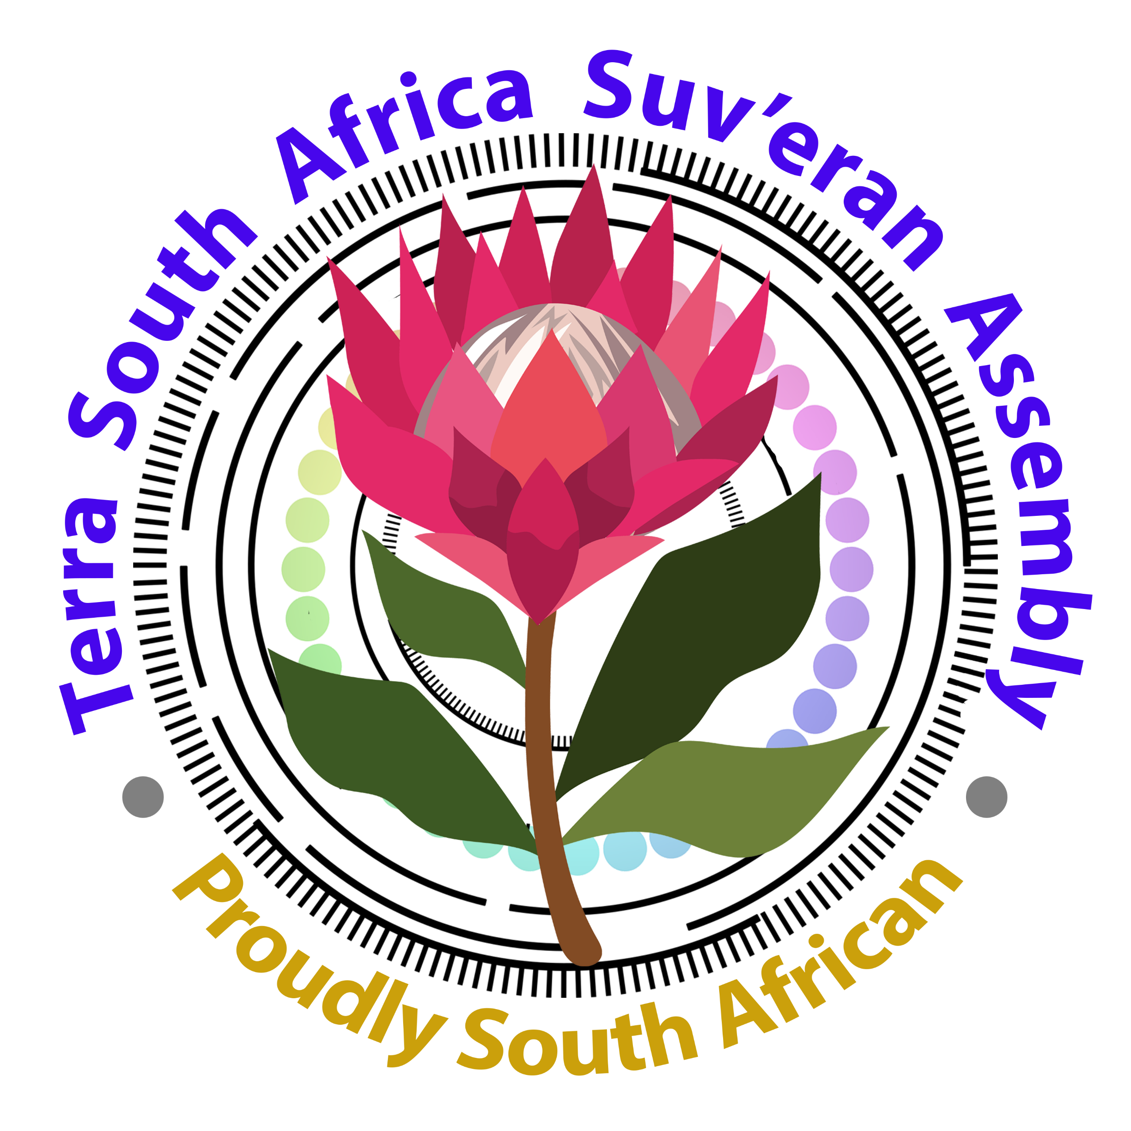
- Step one:
Join here: https://www.becw.co.za/#/register?memberRef=15708
(if you haven’t yet)
Ensure that you double check your name and cellphone details (cell must start with country code 27 (then drop the 0) and enter rest of number. Eg: 27813221886. Take a screenshot for evidence.
Pay your joining fee of R350. Once-off.
BCW
FNB 631 225 405 52
Ref number : 27 and your cellphone number without the 0
EXAMPLE: 27813221886
Choose Pay Immediately, if possible – this speeds up the process (but some banks charge ridiculous amounts, so first check)
Send your Proof of Payment (with you full name and number) to one of the Treasury Committee members via WhatsApp.
Maxine - 0813221886
Monica - 0827719659
2. Step two: Get your wallet PIN
Check for an SMS (will come from Celbux, the developers) and write down your PIN code in a safe place.
Log into www.celbux.com
Here you will be depositing your funds (getting it out of the banking system) and also receive all your future spending rewards. Ensure that you click an action only once! This is a security feature to keep bots out. Click and wait….this is applicable to all your transactions in your wallet.
* If you didn’t get an SMS with your pin, log into your back office (www.becw.co.za), go to Settings and choose Resend Celbux PIN.
3. Step three: Top Up and start spending.
Your wallet is already pre-loaded with R30. You can use this to test the system so that you become familiar and comfortable.
Only use the following banking details to convert your monies into earnable vouchers on Celbux:
Celbux SA
Nedbank
Acc: 120 563 6307
branch: 198765
ref: your registered cell number (starting with 27)
* Choose Immediate Payment option (if possible)
It takes about 15 minutes to clear. With a normal EFT it can take up to a day or 2 to reflect – plan accordingly. Log into the Celbux platform to view vouchers and transactions.
Go to My Vouchers to see all vouchers.
If you have more than one voucher, you are going to collapse them into one voucher:
Simply find the 3 dots on the right side of a voucher, click on it and choose Collapse Vouchers. All vouchers will be automatically be polled together into one voucher. You will receive an SMS with your voucher number.
4. Step four: How to spend.
When you get to the till of a participating merchant, just give the teller your voucher number to type into their terminal, with the amount that you are buying for. Than amount gets deducted from your voucher and you immediately get a new, updated voucher by SMS. You can now shop at any other store. (a full list of the big merchants can be found in your BCW back office (www.becw.co.za)
Some of the staff members may not be trained on the voucher system as yet. If this happens, use the following terminologies to help them. If needed, call a supervisor. See table below. Soon, everyone will know exactly how it works.
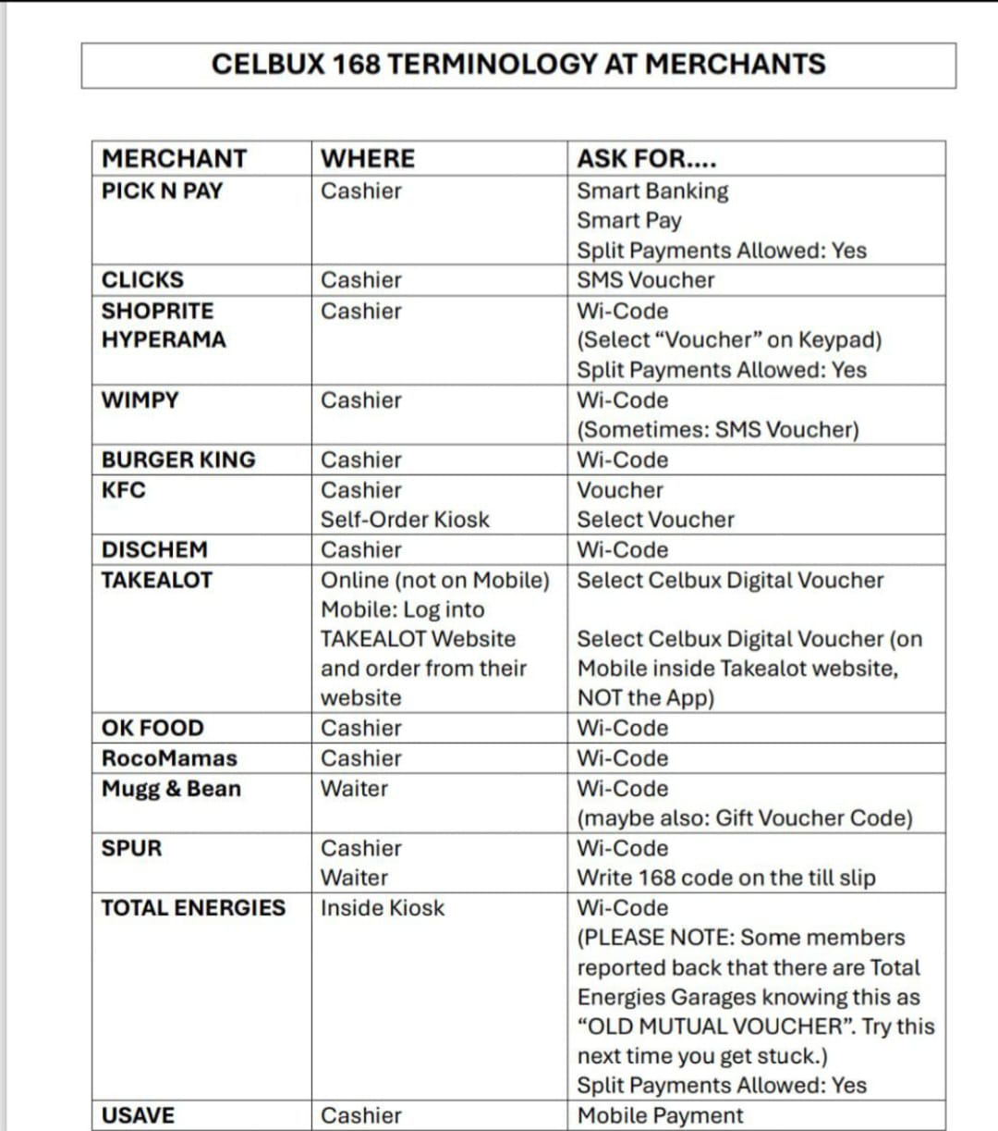
*Specifically for electricity and municipal bills, we use PicknPay. We speed up the process by buying vouchers from Voucher Warehouse. They are extremely reliable and fast. You can load these onto a (free) PnPay gift card to make things easier. Refer to the training video under Step 7.
Orders for these vouchers are placed on the WhatsApp group called VOUCHERWAREHOUSE ORDERS. https://chat.whatsapp.com/ILwqJD5kdgHGKSdcU6UM1q
5. Step five: Tell your loved ones about this!
If you want your friends and loved ones to also use this wallet system (the more we use this system, the faster it will become the norm) let them join with your own personal link. You will be rewarded in your wallet for helping to build our sovereign community.
Log into the BCW back office to get your link. www.becw.co.za.
Go to your Settings tab, copy your link and send to your loved one.
6. Step six: Signing up as a vendor/merchant
If you are running a small business, you can also sign-up to out network of service providers. We do so in a Sovereign way, not the cabal way. For step-by-step assistance, please contact one of the Treasury Committee members:
Monica - 0827719659
Maxine – 0813221886
We will be compiling a full list of sovereign vendors so that we can fully support one another.
7. Step seven: Make this your new habit
Budget ahead, always use this system to pay for everyday expenses. You are forcing the monetary system to change and you are earning back on your spending. It’s a Win-Win situation.
Training videos on how to pay for electricity and municipal bills, etc, can be found here:
https://www.youtube.com/@HumanitarianMax/videos
Subscribe to the channel.
Our system is linked to the original BCW model, thus you can also watch training videos by this gentleman, Riaan:
https://www.youtube.com/@RiaanDigitalCoach
Welcome! Thank you for being part of the positive sovereign changes we are making, for our freedom!
